# Exception Handling in Java

The Exception Handling in Java is one of the powerful mechanism to handle the runtime errors so that normal flow of the application can be maintained.

### Advantage of Exception Handling

The core advantage of exception handling is to maintain the normal flow of the application. An exception normally disrupts the normal flow of the application that is why we use exception handling. Let's take a scenario:

1. statement 1;
2. statement 2;
3. statement 3;
4. statement 4;
5. statement 5;//exception occurs
6. statement 6;
7. statement 7;
8. statement 8;
9. statement 9;
10. statement 10;

## Hierarchy of Java Exception classes

### Types of Java Exceptions

There are mainly two types of exceptions: checked and unchecked. Here, an error is considered as the unchecked exception. According to Oracle, there are three types of exceptions:

1. Checked Exception
2. Unchecked Exception
3. Error

## Java Exception Keywords

There are 5 keywords which are used in handling exceptions in Java.

|  |  |
| --- | --- |
| Keyword | Description |
| try | The "try" keyword is used to specify a block where we should place exception code. The try block must be followed by either catch or finally. It means, we can't use try block alone. |
| catch | The "catch" block is used to handle the exception. It must be preceded by try block which means we can't use catch block alone. It can be followed by finally block later. |
| finally | The "finally" block is used to execute the important code of the program. It is executed whether an exception is handled or not. |
| throw | The "throw" keyword is used to throw an exception. |
| throws | The "throws" keyword is used to declare exceptions. It doesn't throw an exception. It specifies that there may occur an exception in the method. It is always used with method signature. |

**public** **class** JavaExceptionExample{

**public** **static** **void** main(String args[]){

**try**{

      //code that may raise exception

**int** data=100/0;

   }**catch**(ArithmeticException e){System.out.println(e);}

   //rest code of the program

   System.out.println("rest of the code...");

  }

}

Output:

Exception in thread main java.lang.ArithmeticException:/ by zero

rest of the code...

### ArithmeticException

**int** a=50/0;//ArithmeticException

### NullPointerException

String s=**null**;

1. System.out.println(s.length());//NullPointerException

### NumberFormatException

String s="abc";

1. **int** i=Integer.parseInt(s);//NumberFormatException

### ArrayIndexOutOfBoundsException

**int** a[]=**new** **int**[5];

1. a[10]=50; //ArrayIndexOutOfBoundsException

## Java Multi-catch block

**public** **class** MultipleCatchBlock1 {

**public** **static** **void** main(String[] args) {

**try**{

**int** a[]=**new** **int**[5];

                a[5]=30/0;

               }

**catch**(ArithmeticException e)

                  {

                   System.out.println("Arithmetic Exception occurs");

                  }

**catch**(ArrayIndexOutOfBoundsException e)

                  {

                   System.out.println("ArrayIndexOutOfBounds Exception occurs");

                  }

**catch**(Exception e)

                  {

                   System.out.println("Parent Exception occurs");

                  }

               System.out.println("rest of the code");

    }

}

**output:**

Arithmetic Exception occurs

rest of the code

**public** **class** MultipleCatchBlock4 {

**public** **static** **void** main(String[] args) {

**try**{

                String s=**null**;

                System.out.println(s.length());

               }

**catch**(ArithmeticException e)

                  {

                   System.out.println("Arithmetic Exception occurs");

                  }

**catch**(ArrayIndexOutOfBoundsException e)

                  {

                   System.out.println("ArrayIndexOutOfBounds Exception occurs");

                  }

**catch**(Exception e)

                  {

                   System.out.println("Parent Exception occurs");

                  }

               System.out.println("rest of the code");

    }

}

**output:**

Parent Exception occurs

rest of the code

**finally:**

**class** TestFinallyBlock1{

**public** **static** **void** main(String args[]){

**try**{

**int** data=25/0;

System.out.println(data);

  }

**catch**(NullPointerException e){System.out.println(e);}

**finally**{System.out.println("finally block is always executed");}

  System.out.println("rest of the code...");

  }

}

**output:**

Output:finally block is always executed

Exception in thread main java.lang.ArithmeticException:/ by zero

**throw:**

**public** **class** TestThrow1{

**static** **void** validate(**int** age){

**if**(age<18)

**throw** **new** ArithmeticException("not valid");

**else**

      System.out.println("welcome to vote");

   }

**public** **static** **void** main(String args[]){

      validate(13);

      System.out.println("rest of the code...");

  }

}

**output:**Exception in thread main java.lang.ArithmeticException:not valid

**throws:**The **Java throws keyword** is used to declare an exception.

**import** java.io.*;

**class** M{

**void** method()**throws** IOException{

**throw** **new** IOException("device error");

 }

}

**public** **class** Testthrows2{

**public** **static** **void** main(String args[]){

**try**{

     M m=**new** M();

     m.method();

    }**catch**(Exception e){System.out.println("exception handled");}

    System.out.println("normal flow...");

  }

}

**Output:**exception handled

normal flow...

# Multithreading in Java

Multithreading in [Java](https://www.javatpoint.com/java-tutorial) is a process of executing multiple threads simultaneously.

A thread is a lightweight sub-process, the smallest unit of processing. Multiprocessing and multithreading, both are used to achieve multitasking.

|  |  |
| --- | --- |
| Process | Thread |
| 1. Process has its own main memory for execution. 2. Process is considered as heavyweight component. 3. One process can have multiple threads. 4. Context switch time is more. | 1. Thread use process’s main memory for execution and share it with other threads. 2. Thread is considered as lightweight component. 3. One thread can’t have multiple process. 4. Context switch time is less. |

# Life cycle of a Thread

1. New
2. Runnable
3. Running
4. Non-Runnable (Blocked)
5. Terminated

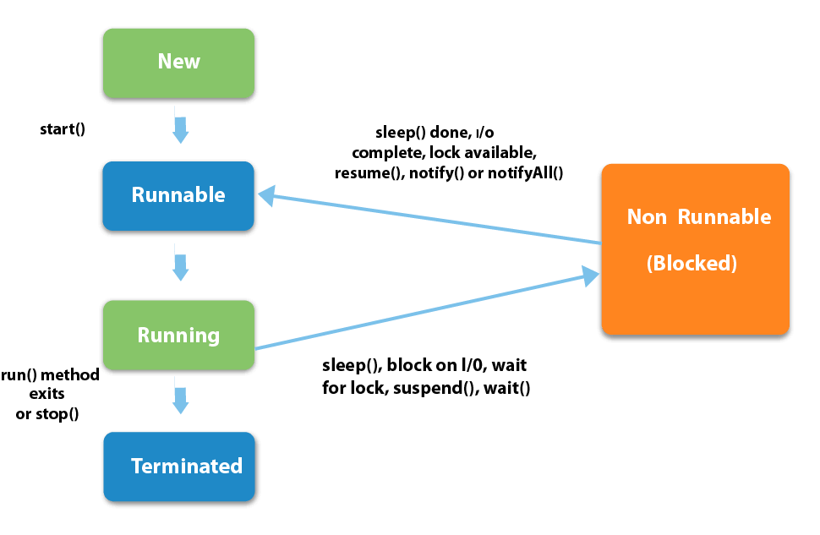

|  |  |  |  |
| --- | --- | --- | --- |
| S.N. | Modifier and Type | Method | Description |
| 1) | void | [start()](https://www.javatpoint.com/java-thread-start-method) | It is used to start the execution of the thread. |
| 2) | void | [run()](https://www.javatpoint.com/java-thread-run-method) | It is used to do an action for a thread. |
| 3) | static void | [sleep()](https://www.javatpoint.com/java-thread-sleep-method) | It sleeps a thread for the specified amount of time. |
| 4) | static Thread | [currentThread()](https://www.javatpoint.com/java-thread-currentthread-method) | It returns a reference to the currently executing thread object. |
| 5) | void | [join()](https://www.javatpoint.com/java-thread-join-method) | It waits for a thread to die. |
| 6) | int | [getPriority()](https://www.javatpoint.com/java-thread-getpriority-method) | It returns the priority of the thread. |
| 7) | void | [setPriority()](https://www.javatpoint.com/java-thread-setpriority-method) | It changes the priority of the thread. |
| 8) | String | [getName()](https://www.javatpoint.com/java-thread-getname-method) | It returns the name of the thread. |
| 9) | void | [setName()](https://www.javatpoint.com/java-thread-setname-method) | It changes the name of the thread. |
| 10) | long | [getId()](https://www.javatpoint.com/java-thread-getid-method) | It returns the id of the thread. |
| 11) | boolean | [isAlive()](https://www.javatpoint.com/java-thread-isalive-method) | It tests if the thread is alive. |
| 12) | static void | [yield()](https://www.javatpoint.com/java-thread-yield-method) | It causes the currently executing thread object to pause and allow other threads to execute temporarily. |
| 13) | void | [suspend()](https://www.javatpoint.com/java-thread-suspend-method) | It is used to suspend the thread. |
| 14) | void | [resume()](https://www.javatpoint.com/java-thread-resume-method) | It is used to resume the suspended thread. |
| 15) | void | [stop()](https://www.javatpoint.com/java-thread-stop-method) | It is used to stop the thread. |

|  |
| --- |
| How to create thread There are two ways to create a thread:   1. By extending Thread class 2. By implementing Runnable interface. |

### Java Thread Example by extending Thread class

**class** Multi **extends** Thread{

**public** **void** run(){

System.out.println("thread is running...");

}

**public** **static** **void** main(String args[]){

Multi t1=**new** Multi();

t1.start();

 }

}

Output:thread is running...

### 2) Java Thread Example by implementing Runnable interface

**class** Multi3 **implements** Runnable{

**public** **void** run(){

System.out.println("thread is running...");

}

**public** **static** **void** main(String args[]){

Multi3 m1=**new** Multi3();

Thread t1 =**new** Thread(m1);

t1.start();

 }

}

Output:thread is running...

**sleep():**

**class** TestSleepMethod1 **extends** Thread{

**public** **void** run(){

**for**(**int** i=1;i<5;i++){

**try**{Thread.sleep(500);}**catch**(InterruptedException e)

{System.out.println(e);}

    System.out.println(i);

  }

 }

**public** **static** **void** main(String args[]){

  TestSleepMethod1 t1=**new** TestSleepMethod1();

  TestSleepMethod1 t2=**new** TestSleepMethod1();

  t1.start();

  t2.start();

 }

}

**output:**

1

1

2

2

3

3

4

4

# Synchronization in Java

Synchronization in java is the capability to control the access of multiple threads to any shared resource.

Java Synchronization is better option where we want to allow only one thread to access the shared resource.

Thread Synchronization

There are two types of thread synchronization mutual exclusive and inter-thread communication.

1. Mutual Exclusive
   1. Synchronized method.
   2. Synchronized block.
   3. static synchronization.
2. Cooperation (Inter-thread communication in java)

### Mutual Exclusive

Mutual Exclusive helps keep threads from interfering with one another while sharing data. This can be done by three ways in java:

1. by synchronized method
2. by synchronized block
3. by static synchronization

### Java synchronized method

If you declare any method as synchronized, it is known as synchronized method.

Synchronized method is used to lock an object for any shared resource.

**class** Table{

**synchronized** **void** printTable(**int** n){//synchronized method

**for**(**int** i=1;i<=5;i++){

     System.out.println(n*i);

**try**{

      Thread.sleep(400);

     }**catch**(Exception e){System.out.println(e);}

   }

 }

}

**public** **class** TestSynchronization3{

**public** **static** **void** main(String args[]){

**final** Table obj = **new** Table();//only one object

Thread t1=**new** Thread(){

**public** **void** run(){

obj.printTable(5);

}

};

Thread t2=**new** Thread(){

**public** **void** run(){

obj.printTable(100);

}

};

t1.start();

t2.start();

}

}

Output: 5

10

15

20

25

100

200

300

400

500

# Synchronized Block in Java

Synchronized block can be used to perform synchronization on any specific resource of the method.

**class** Table{

**void** printTable(**int** n){

**synchronized**(**this**){//synchronized block

**for**(**int** i=1;i<=5;i++){

      System.out.println(n*i);

**try**{

       Thread.sleep(400);

      }**catch**(Exception e){System.out.println(e);}

     }

   }

 }//end of the method

}

# Static Synchronization

If you make any static method as synchronized, the lock will be on the class not on object.

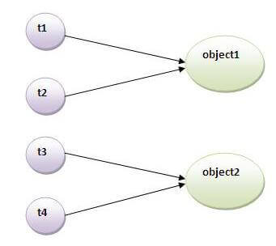

### Problem without static synchronization

**class** Table{

**synchronized** **static** **void** printTable(**int** n){

**for**(**int** i=1;i<=10;i++){

     System.out.println(n*i);

**try**{

       Thread.sleep(400);

     }**catch**(Exception e){}

   }

 }

}

**class** MyThread1 **extends** Thread{

**public** **void** run(){

Table.printTable(1);

}

}

**class** MyThread2 **extends** Thread{

**public** **void** run(){

Table.printTable(10);

}

}

**class** MyThread3 **extends** Thread{

**public** **void** run(){

Table.printTable(100);

}

}

**class** MyThread4 **extends** Thread{

**public** **void** run(){

Table.printTable(1000);

}

}

**public** **class** TestSynchronization4{

**public** **static** **void** main(String t[]){

MyThread1 t1=**new** MyThread1();

MyThread2 t2=**new** MyThread2();

MyThread3 t3=**new** MyThread3();

MyThread4 t4=**new** MyThread4();

t1.start();

t2.start();

t3.start();

t4.start();

}

}

Output: 1

2

3

4

5

6

7

8

9

10

10

20

30

40

50

60

70

80

90

100

100

200

300

400

500

600

700

800

900

1000

1000

2000

3000

4000

5000

6000

7000

8000

9000

10000

**Inter-thread communication** or **Co-operation** is all about allowing synchronized threads to communicate with each other.

wait()

* notify()
* notifyAll()

### Difference between wait and sleep?

Let's see the important differences between wait and sleep methods.

|  |  |
| --- | --- |
| **wait()** | **sleep()** |
| The wait() method releases the lock. | The sleep() method doesn't release the lock. |
| It is a method of Object class | It is a method of Thread class |
| It is the non-static method | It is the static method |
| It should be notified by notify() or notifyAll() methods | After the specified amount of time, sleep is completed. |

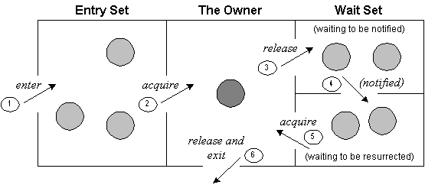

class Customer{

int amount=10000;

synchronized void withdraw(int amount){

System.out.println("going to withdraw...");

if(this.amount<amount){

System.out.println("Less balance; waiting for deposit...");

try{wait();}catch(Exception e){}

}

this.amount-=amount;

System.out.println("withdraw completed...");

}

synchronized void deposit(int amount){

System.out.println("going to deposit...");

this.amount+=amount;

System.out.println("deposit completed... ");

notify();

}

}

class Test{

public static void main(String args[]){

final Customer c=new Customer();

new Thread(){

public void run(){c.withdraw(15000);}

}.start();

new Thread(){

public void run(){c.deposit(10000);}

}.start();

}}

**Output:** going to withdraw...

Less balance; waiting for deposit...

going to deposit...

deposit completed...

withdraw completed